- INTRODUCTION

The graphics processing unit (GPU) has become an integral part of today’s mainstream computing systems. Over the past many years, there has been a marked increase in the performance and capabilities of GPUs. The modern GPU is not only a powerful graphics engine but also a highly parallel programmable processor featuring peak arithmetic and memory bandwidth that substantially outpaces its CPU counterpart. The GPU’s rapid increase in both programmability and capability has spawned a research community that has successfully mapped a broad range of computationally demanding, complex problems to the GPU. This effort in general purpose computing on the GPU, also known as GPU computing, has positioned the GPU as a compelling alternative to traditional microprocessors in high-performance computer systems of the future.

A GPU is tailored for highly parallel operation while a CPU executes programs serially. For this reason, GPUs have many parallel execution units and higher transistor counts, while CPUs have few execution units and higher clock speeds. A GPU is for the most part deterministic in its operation (though this is quickly changing).GPUs have much deeper pipelines (several thousand stages vs 10-20 for CPUs).GPUs have significantly faster and more advanced memory interfaces as they need to shift around a lot more data than CPUs.
GPU computing is the use of a GPU (graphics processing unit) to do general purpose scientific and engineering computing. The model for GPU computing is to use a CPU and GPU together in a heterogeneous computing model. The sequential part of the application runs on the CPU and the computationally-intensive part runs on the GPU. From the user’s perspective, the application just runs faster because it is using the high-performance of the GPU to boost performance. GPU computing is enabled by the massively parallel architecture of NVIDIA’s GPUs called the CUDA architecture. The CUDA architecture consists of 100s of processor cores that operate together to crunch through the data set in the application. The Tesla 10-series GPU is the second generation CUDA architecture with features optimized for scientific applications such as IEEE standard double precision floating point hardware support, local data caches in the form of shared memory dispersed throughout the GPU, coalesced memory accesses and so on.

The GPU is designed for a particular class of applications with the following characteristics:
- Computational requirements are large.
- Parallelism is substantial.
- Throughput is more important than latency.

The GPU was a fixed-function processor earlier, built around the graphics pipeline, that excelled at three dimensional graphics but little else. Since that time, the GPU has evolved into a powerful programmable processor, with both application programming interface and hardware increasingly focusing on the programmable aspects of the GPU. The result is a processor with enormous arithmetic capability [a single NVIDIA GeForce 8800 GTX can sustain over 330 Giga floating-point operations per second (Gflops)] and streaming memory bandwidth (80+ GB/s), both substantially greater than a high-end CPU. The GPU has a distinctive architecture centered around a large number of fine-grained parallel processors.
As the shader model has evolved and become more powerful, and GPU applications of all types have increased vertex and fragment program complexity, GPU architectures have increasingly focused on the programmable parts of the graphics pipeline. Indeed, while previous generations of GPUs could best be described as additions of programmability to a fixed-function pipeline, today’s GPUs are better characterized as a programmable engine surrounded by supporting fixed-function units.

Successful GPU computing applications do the following:

- Emphasize parallelism
- Minimize SIMD divergence
- Maximize arithmetic intensity
- Exploit streaming bandwidth

Meanwhile...

Meanwhile, as CPU makers were tearing their hair out trying to find a solution to their problems, GPU makers were continuing to benefit more than ever from the advantages of Moore’s Law.
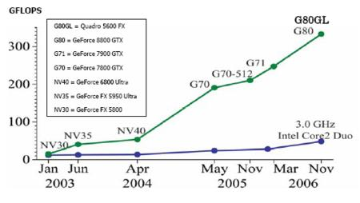

CPUs are designed to get maximum performance from a stream of instructions, which operates on diverse data (such as integers and floating-point calculations) and performs random memory accesses, branching, etc. Up to that point, architects were working to extract more parallelism of instructions – that is, to launch as many instructions as possible in parallel. Accordingly, the Pentium introduced superscalar execution, making it possible to launch two instructions per cycle under certain conditions. The Pentium Pro ushered in out-of-order execution of instructions in order to make optimum use of calculating units. The problem is that there’s a limit to the parallelism that is possible to get out of a sequential stream of instructions, and consequently, blindly increasing the number of calculating units is useless, since they remain unused most of the time.
Conversely, the operation of a GPU is sublimely simple. The job consists of taking a group of polygons, on the one hand, and generating a group of pixels on the other. The polygons and pixels are independent of each other, and so can be processed by parallel units. That means that a GPU can afford to devote a large part of its die to calculating units which, unlike those of a CPU, will actually be used.

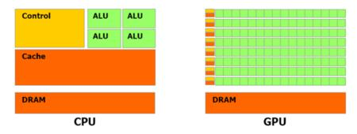

GPUs differ from CPUs in another way. Memory access in a GPU is extremely coherent – when a texel is read, a few cycles later the neighboring texel will be read, and when a pixel is written, a few cycles later a neighboring pixel will be written. By organizing memory intelligently, performance comes close to the theoretical bandwidth. That means that a GPU, unlike a CPU, doesn’t need an enormous cache, since its role is principally to accelerate texturing operations. A few kilobytes are all that’s needed to contain the few texels used in bilinear and trilinear filters.
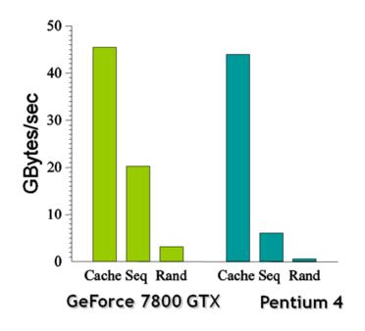

COMPARISON: CPU AND GPU

To execute a graphical pipeline, a CPU would take a single element (or group of elements) and process the first stage in the pipeline, then the next stage, and so on. The CPU divides the pipeline in time, applying all resources in the processor to each stage in turn. GPUs have historically taken a different approach. The GPU divides the resources of the processor among the different stages, such that the pipeline is divided in space, not time. The part of the processor working on one stage feeds its output directly into a different part that works on the next stage.

In a CPU, any given operation may take on the order of 20 cycles between entering and
leaving the CPU pipeline. On a GPU, a graphics operation may take thousands of cycles from start to finish. The latency of any given operation is long. However, the task and data parallelism across and between stages delivers high throughput. GPUs have much deeper pipelines (several thousand stages vs 10-20 for CPUs)

A GPU is tailored for highly parallel operation while a CPU executes programs serially.For this reason, GPUs have many parallel execution units and higher transistor counts, while CPUs have few execution units and higher clockspeeds. A GPU is for the most part deterministic in its operation (though this is quickly changing).

GPUs have significantly faster and more advanced memory interfaces as they need to shift around a lot more data than CPUs.

The advent of GPGPU
The idea of using graphics accelerators for mathematical calculation is not recent. The first traces of it go back to the 1990s. Initially it was very primitive – limited mostly to the use of certain hard-wired functions like rasterization and Z-buffers to accelerate tasks like pathfinding or drawing Voronoi diagrams.



In 2003, with the appearance of highly evolved shaders, a new stage was reached – this time performing matrix calculations using the hardware then available. That was the year when an entire section of the SIGGRAPH (“Computations on GPUs”) was dedicated to this new IT fringe area. This early initiative was to take on the name GPGPU (for General-Purpose computation on GPUs). One early turning point in this area was the appearance of BrookGPU.
To really understand the role of Brook, you need to see how things were done before it made its appearance. The only way to get access to the GPU’s resources in 2003 was to use one of the two graphics APIs – Direct3D or OpenGL. Consequently, researchers who wanted to harness the GPU’s processing power had to work with these APIs. The problem was that those individuals weren’t necessarily experts in graphics programming, which seriously complicated access to the technology. Where 3D programmers talk in terms of shaders, textures and fragments; specialists in parallel programming talk about streams, kernels, scatter, and gather. So, the first difficulty was to find analogies between two distinct worlds:
- a stream – that is, a flow of elements of the same type – can be represented on the GPU by a texture. To give you an idea of this, consider that the equivalent in classic programming languages is simply an array.
- a kernel – the function that will be applied independently to each element of the stream – is the equivalent of a pixel shader. Conceptually, it can be seen as an internal loop in a classic program – the one that will be applied to the largest number of elements.
- to read the results of the application of a kernel to a stream, it has to be rendered in a texture. Obviously there’s no equivalent on a CPU, which has total access to the memory.
- to control the location where a memory write is to take place (in a scatter operation), it has to be done in a vertex shader, since a pixel shader can’t modify the coordinates of the pixel currently being processed.
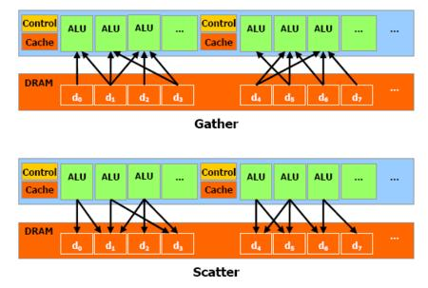

The CUDA APIs

But, Brook’s critical success was enough to attract the attention of ATI and Nvidia, since the two giants saw the incipient interest in this type of initiative as an opportunity to broaden their market even more by reaching a new sector that had so far been indifferent to their graphics achievements.
Researchers who were in on Brook at its origin quickly joined the Santa Clara development teams to put together a global strategy for targeting the new market. The idea was to offer a hardware/software ensemble suited to this type of calculation – since Nvidia’s developers know all the secrets of their GPU, there was no question of relying only on a graphics API, which only communicates with the hardware via a driver, with all the problems that implies, as we saw above. So the CUDA (Compute Unified Device Architecture) development team created a set of software layers to communicate with the GPU.
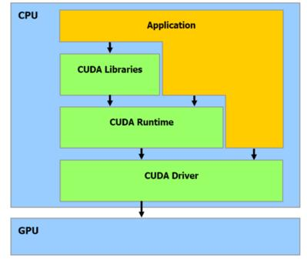

, CUDA provides two APIs:
- A high-level API: the CUDA Runtime API;
- A low-level API: the CUDA Driver API.
Since the high-level API is implemented “above” the low-level API, each call to a function of the Runtime is broken down into more basic instructions managed by the Driver API. Note that these two APIs are mutually exclusive – the programmer must use one or the other, but it’s not possible to mix function calls from both. The term “high-level API” is relative. Even the Runtime API is still what a lot of people would consider very low-level; yet it still offers functions that are highly practical for initialization or context management. But don’t expect a lot more abstraction – you still need a good knowledge of Nvidia GPUs and how they work.


The Driver API, then, is more complex to manage; it requires more work to launch processing on the GPU. But the upside is that it’s more flexible, giving the programmer who wants it additional control. The two APIs are capable of communicating with OpenGL or Direct3D resources (only nine for the moment). The usefulness of this is obvious – CUDA could be used to generate resources (geometry, procedural textures, etc.) that could then be passed to the graphics API, or conversely, it’s possible that the 3D API could send the results of the rendering to CUDA, which in that case would be used to perform post-processing. There are numerous examples of interactions, and the advantage is that the resources remain stored in the GPU’s RAM without having to transit through the bottleneck of the PCI-Express bus.


Conversely, we should point out that sharing resources – in this case video memory – with graphics data is not always idyllic and can lead to a few headaches. For example, for a change of resolution or color depth, the graphics data have priority. So, if the resources for the frame buffer need to increase, the driver won’t hesitate to grab the ones that are allocated to applications using CUDA, causing them to crash. It’s not very elegant, granted; but you have to admit that the situation shouldn’t come up very often. And since we’re on the subject of little disadvantages: If you want to use several GPUs for a CUDA application, you’ll have to disable SLI mode first, or only a single GPU will be visible to CUDA.



A Few Definitions
Bottom of Form
Before we dive into CUDA, let’s define a few terms that are sprinkled throughout Nvidia’s documentation. The company has chosen to use a rather special terminology that can be hard to grasp. First we need to define what a thread is in CUDA, because the term doesn’t have quite the same meaning as a “CPU thread,” nor is it the equivalent of what we call "threads" in our GPU articles. A thread on the GPU is a basic element of the data to be processed. Unlike CPU threads, CUDA threads are extremely “lightweight,” meaning that a context change between two threads is not a costly operation.
The second term frequently encountered in the CUDA documentation is warp. No confusion possible this time (unless you think the term might have something to do with Start Trek or Warhammer). No, the term is taken from the terminology of weaving, where it designates “threads arranged lengthwise on a loom and crossed by the woof.” A warp in CUDA, then, is a group of 32 threads, which is the minimum size of the data processed in SIMD fashion by a CUDA multiprocessor.

But that granularity is not always sufficient to be easily usable by a programmer, and so in CUDA, instead of manipulating warps directly, you work with blocks that can contain 64 to 512 threads.
Finally, these blocks are put together in grids. The advantage of the grouping is that the number of blocks processed simultaneously by the GPU are closely linked to hardware resources, as we’ll see later. The number of blocks in a grid make it possible to totally abstract that constraint and apply a kernel to a large quantity of threads in a single call, without worrying about fixed resources. The CUDA runtime takes care of breaking it all down for you. This means that the model is extremely extensible. If the hardware has few resources, it executes the blocks sequentially; if it has a very large number of processing units, it can process them in parallel. This in turn means that the same code can target both entry-level GPUs, high-end ones and even future GPUs.
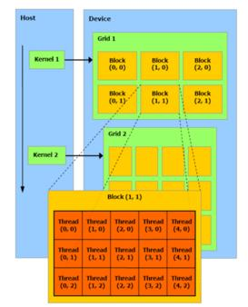

The other terms you’ll run into frequently in the CUDA API are used to designate the CPU, which is called the host, and the GPU, which is referred to as the device. After that little introduction, which we hope hasn’t scared you away, it’s time to plunge in!

CUDA from the Hardware Point of View
Bottom of Form
If you’re a faithful reader of Tom’s Hardware, the architecture of the latest Nvidia GPUs won’t be unfamiliar to you. If not, we advise you to do a little homework. With CUDA, Nvidia presents its architecture in a slightly different way and exposes certain details that hadn’t been revealed before now.
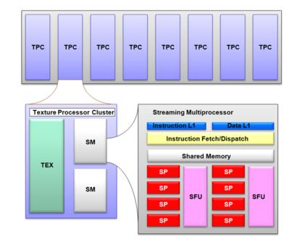
CUDA from the Hardware Point of View
9:40 AM - June 18, 2008 by Fedy Abi-Chahla

As you can see above, Nvidia’s Shader Core is made up of several clusters Nvidia calls Texture Processor Clusters. An 8800GTX, for example, has eight clusters, an 8800GTS six, and so on. Each cluster, in fact, is made up of a texture unit and two streaming multiprocessors. These processors consist of a front end that reads/decodes and launches instructions and a backend made up of a group of eight calculating units and two SFUs (Super Function Units) where the instructions are executed in SIMD fashion: The same instruction is applied to all the threads in the warp. Nvidia calls this mode of execution SIMT (for single instruction multiple threads). It’s important to point out that the backend operates at double the frequency of the front end. In practice, then, the part that executes the instructions appears to be twice as “wide” as it actually is (that is, as a 16-way SIMD unit instead of an eight-way one). The streaming multiprocessors’ operating mode is as follows: At each cycle, a warp ready for execution is selected by the front end, which launches execution of an instruction. To apply the instruction to all 32 threads in the warp, the backend will take four cycles, but since it operates at double the frequency of the front end, from its point of view only two cycles will be executed. So, to avoid having the front end remain unused for one cycle and to maximize the use of the hardware, the ideal is to alternate types of instructions every cycle – a classic instruction for one cycle and an SFU instruction for the other.
Each multiprocessor also has certain amount of resources that should be understood in order to make the best use of them. They have a small memory area called Shared Memory with a size of 16 KB per multiprocessor. This is not a cache memory – the programmer has a free hand in its management. As such, it’s like the Local Store of the SPUs on Cell processors. This detail is particularly interesting, and demonstrates the fact that CUDA is indeed a set of software and hardware technologies. This memory area is not used for pixel shaders – as Nvidia says, tongue in cheek, “We dislike pixels talking to each other.”

CUDA from the Software Point of View
Bottom of Form

From a software point of view, CUDA consists of a set of extensions to the C language, which of course recalls BrookGPU, and a few specific API calls. Among the extensions are type qualifiers that apply to functions and variables. The keyword to remember here is __global__, which when prefixed to a function indicates that the latter is a kernel – that is, a function that will be called by the CPU and executed by the GPU. The __device__ keyword designates a function that will be executed by the GPU (which CUDA refers to as the “device”) but can only be called from the GPU (in other words, from another __device__ function or from a __global__ function). Finally, the __host__ keyword is optional, and designates a function that’s called by the CPU and executed by the CPU – in other words, a traditional function.

There are a few restrictions associated with __device__ and __global__ functions: They can’t be recursive (that is, they can’t call themselves) and they can’t have a variable number of arguments. Finally, regarding __device__ functions resident in the GPU’s memory space, logically enough it’s impossible to obtain their address. Variables also have new qualifiers that allow control of the memory area where they’ll be stored. A variable preceded by the keyword __shared__ indicates that it will be stored in the streaming multiprocessors’ shared memory. The way a __global__ function is called is also a little different. That’s because the execution configuration has to be defined at the time of the call – more concretely, the size of the grid to which the kernel is applied and the size of each block. Take the example of a kernel with the following signature:

__global__ void Func(float* parameter);

which will be called as follows:

Func<<< Dg, Db >>>(parameter);

where Dg is the grid dimension and Db the dimension of a block. These two variables are of a new vector type introduced by CUDA.

The CUDA API essentially comprises functions for memory manipulation in VRAM: cudaMalloc to allocate memory, cudaFree to free it and cudaMemcpy to copy data between RAM and VRAM and vice-versa.

We’ll end this overview with the way a CUDA program is compiled, which is interesting: Compiling is done in several phases – first of all the code dedicated to the CPU is extracted from the file and passed to the standard compiler. The code dedicated to the GPU is first converted into an intermediate language, PTX. This intermediate language is like an assembler, and so enables the generated source code to be studied for potential inefficiencies. Finally, the last phase translates this intermediate language into commands that are specific to the GPU and encapsulates them in binary form in the executable.

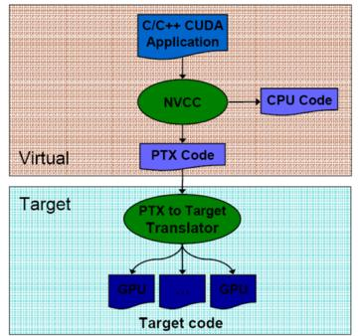

In Practice
Bottom of Form
Once you’ve pored over Nvidia’s documentation, it’s hard to resist getting your hands a little dirty. After all, what better way is there of judging an API than trying to write a little program using it? That’s where most of the problems come to the surface, even if everything looks perfect on paper. It’s also the best way to see if you’ve assimilated all the concepts described in the CUDA documentation.
And it’s actually quite easy to dive into such a project. A lot of high-quality free tools are available. For this test we used Visual C++ Express 2005, which had everything we needed. The hardest part was finding a program that was simple enough to port to the GPU without spending weeks to do so, but at the same time interesting enough to make the adventure worthwhile. We ended up choosing a code snippet we had that takes a height map and calculates the corresponding normal map. We won’t go into the details of the function, which is not of much interest in itself at this point. To be brief, we’re dealing with a convolution: For each pixel of the starting image, we apply a matrix that will determine the color of the resulting pixel in the generated image from the adjacent pixels, using a more or less complicated formula. The advantage of this function is that it’s very easily parallelizable, making it an ideal test of what CUDA is capable of.

The other advantage is that we already had a CPU implementation we could easily compare the result of our CUDA version with – which avoided, as programmers say, having to reinvent the wheel. (When a programmer uses that expression, it means that the time saved can be spent more productively in exhaustive testing of a recent FPS game or close observation of an athletic contest via the medium of HDTV – and we’re no exception.)
We should repeat that the purpose of this test was to familiarize us with tools in the CUDA SDK, and not to do a comparative benchmark between a CPU version and a GPU version. Since this was our first attempt at a CUDA program, we didn’t have high expectations about performance. And, since this wasn’t a critical piece of code, the CPU version wasn’t all that optimized, and so a direct comparison of the results wouldn’t really be of interest.

Performance

However we did decide to measure the processing time to see if there was any advantage to using CUDA even with our crude implementation, or on the other hand if was going to take long, exhaustive practice to get any real control over the use of the GPU. The test machine was our development box – a laptop computer with a Core 2 Duo T5450 and a GeForce 8600M GT, operating under Vista. It’s far from being a supercomputer, but the results are interesting since our test is not all that favorable to the GPU. It’s fine for Nvidia to show us huge accelerations on systems equipped with monster GPUs and enormous bandwidth, but in practice many of the 70 million CUDA GPUs existing on current PCs are much less powerful, and so our test is quite germane.
The results we got are as follows for processing a 2048x2048 image:
- CPU 1 thread: 1419 ms
- CPU 2 threads: 749 ms
- CPU 4 threads: 593 ms
- GPU (8600M GT) blocks of 256 pixels: 109 ms
- GPU (8600M GT) blocks of 128 pixels: 94 ms
- GPU (8800 GTX) blocks of 128 pixels / 256 pixels: 31 ms
Several observations can be made about these results. First of all you’ll notice that despite our crack about programmers’ laziness, we did modify the initial CPU implementation by threading it. As we said, the code is ideal for this situation – all you do is break down the initial image into as many zones as there are threads. Note that we got an almost linear acceleration going from one to two threads on our dual-core CPU, which shows the strongly parallel nature of our test program. Fairly unexpectedly, the four-thread version proved faster, whereas we were expecting to see no difference at all on our processor, or even – and more logically – a slight loss of efficiency due to the additional cost generated by the creation of the additional threads. What explains that result? It’s hard to say, but it may be that the Windows thread scheduler has something to do with it; but in any case the result was reproducible. With a texture with smaller dimensions (512x512), the gain achieved by threading was a lot less marked (approximately 35% as opposed to 100%) and the behavior of the four-thread version was more logical, showing no gain over the two-thread version. The GPU was still faster, but less markedly so (the 8600M GT was three times faster than the two-thread version).
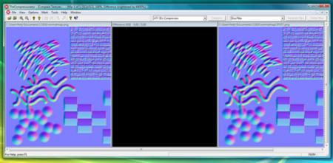
The second notable observation is that even the slowest GPU implementation was nearly six times faster than the best-performing CPU version. For a first program and a trivial version of the algorithm, that’s very encouraging. Notice also that we got significantly better results using smaller blocks, whereas intuitively you might think that the reverse would be true. The explanation is simple – our program uses 14 registers per thread, and with 256-thread blocks it would need 3,584 registers per block, and to saturate a multiprocessor it takes 768 threads, as we saw. In our case, that’s three blocks or 10,572 registers. But a multiprocessor has only 8,192 registers, so it can only keep two blocks active. Conversely, with blocks of 128 pixels, we need 1,792 registers per block; 8,192 divided by 1,792 and rounded to the nearest integer works out to four blocks being processed. In practice, the number of threads are the same (512 per multiprocessor, whereas theoretically it takes 768 to saturate it), but having more blocks gives the GPU additional flexibility with memory access – when an operation with a long latency is executed, it can launch execution of the instructions on another block while waiting for the results to be available. Four blocks would certainly mask the latency better, especially since our program makes several memory accesses.
APPLICATIONS

GPUs are being applied in a wide variety of applications:
- Video Encoding
- Video Decoding
- Ray Tracing
- PhysX
- Modeling

Video Encoding Apps
- Badaboom
- Muvee Reveal
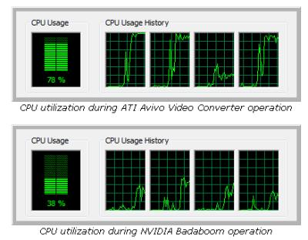
- Powerdirector

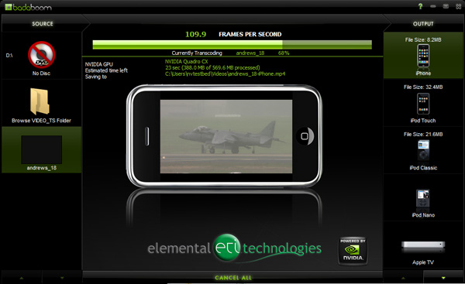

Ray Tracing
- technique for generating an image by tracing the path of light through pixels.
- 

PhysX

- Offloading physics calculations from the CPU
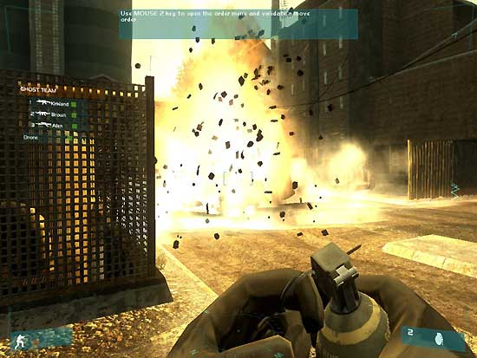
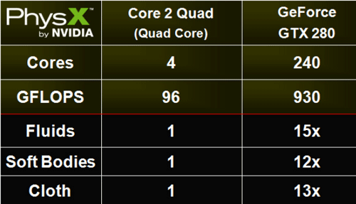

Modeling


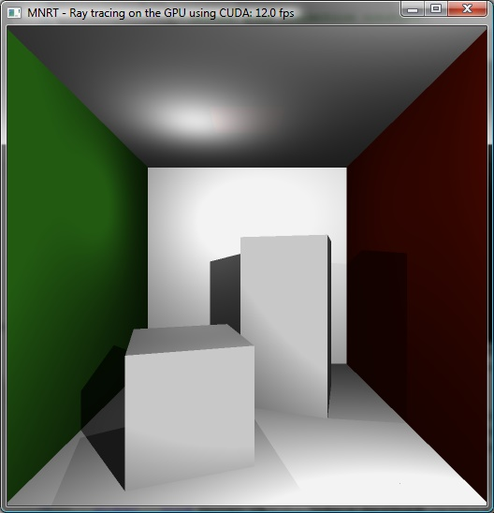
Technique of using a graphics processing unit (GPU) for simulations

CUDA Limitations and Requirements

There are several important constraints on CUDA use within Manifold:

• We must have a CUDA-enabled NVIDIA card installed in our system. 200 and 400 series NVIDIA cards at the present writing are the best-known CUDA-enabled cards, but other NVIDIA GPUs are also CUDA-capable (check with the NVIDIA web site and with your graphics card vendor's web site to see if a particular card is CUDA-capable). Hardware evolves so rapidly under the pressure of gaming industry economy-of-scale that almost before this documentation can be published there will be even faster CUDA-capable cards. manifold.net recommends getting Fermi-class (400 series) GPUs. May as well get the best!
• The rest of our PC system must have sufficient speed and power to support the NVIDIA card. For example, memory must be fast enough to handle CUDA bandwidth and power supplies must provide enough power to run the NVIDIA card (or cards) with extra PCI-E power cables. Consult any technology-obsessed, 14 year old gamer for advice on configuring a suitably "hot" system.
• We must have installed NVIDIA's most recent set of drivers for Windows, which may be downloaded from the nvidia.com web site. NVIDIA's latest drivers automatically install software required for CUDA use by CUDA-capable NVIDIA-based cards.
• If we are running a 64-bit Windows system we must have installed NVIDIA's 64-bit, CUDA-enabled drivers for our 64-bit Windows system.
• Writing massively parallel algorithms to implement spatial functions is extremely difficult, even for manifold.net. Therefore, at the present time only a few dozen functions have been implemented within Manifold that can leverage CUDA. Many more are on the way.
• Existing CUDA-enabled functions within Manifold are Surface - Transform dialog operators for surfaces. The Surface - Transform dialog is part of the optional Surface Tools extension for Manifold (and also a built-in part of some Manifold System editions such as Universal Edition and Ultimate Edition). If we do not have the Surface Tools extension we will not have the ability to use this dialog and hence no ability to leverage CUDA. New updates and future Manifold releases will likely add many more usages of CUDA in addition to the Surface - Transform dialog operators.
• Functions executed within CUDA cards are virtually instantaneous compared to speed of execution within the main processor. However, the NVIDIA stream processors execute tasks so rapidly that it is difficult to provide data fast enough from disk and memory to keep the processors occupied. The resulting performance in most "real life" applications therefore tends to be limited not by processor speed but rather by the speed with which data can be fetched from hard disk or other memory. In addition, a good portion of various tasks are not bound by computation but instead involve overhead tasks such as writing out results to disk, re-computing levels and other necessary but mundane tasks that are not accelerated by CUDA processors. The net result is that as a practical matter for many tasks CUDA-enabled processors will visibly increase speeds, almost always by a factor of two to ten and at times by a factor of ten to fifty, but not usually by factors of hundreds for the overall task even if the actual computation of parts of the task goes hundreds of times faster.
• We can get the most out of CUDA if the rest of our machine does not slow down the ability to feed the insatiable power of NVIDIA stream processors. For maximum speed we should use 64-bit Windows on at least a quad core machine with lots of RAM and large, fast disk drives. Before configuring a new 64-bit system, check the NVIDIA web site to make sure that 64-bit drivers are available for the Windows operating system you plan to install. At the present writing, Windows XP x64 has been used as a baseline common denominator for development of x64 support by manifold.net with all development in Vista and Windows 7 as well.

Despite the above limitations it is clear that CUDA is a revolutionary technology. NVIDIA GPUs are so fast that a routine comment from developers is that NVIDIA renders the main processor almost superfluous, as if even the fastest multi-core Intel chip is relegated to being nothing but an accessory processor to handle the keyboard and mouse. That is not hyperbole given that NVIDIA GPUs can run jobs 200 or even 300 times faster than even the fastest Intel CPUs. See the demo below for an example.

Such speed advantages are not a competitive challenge that traditional processor vendors can afford to ignore. CUDA is the first of what is likely to be a new wave of massively parallel architectures from competitors such as Intel and AMD. Manifold's parallel code has been expressly written to allow easy implementation on future "many-core" processor solutions from Intel and AMD that will compete with NVIDIA CUDA.

FUTURE OF GPU COMPUTING

The fate of coprocessors in commodity computers (such as floating-point coprocessors) has been to move into the chipset or onto the microprocessor. The GPU has resisted that trend with continued improvements in performance and functionality and by becoming an increasingly important part of today’s computing environments-unlike with CPUs, the demand for continued GPU performance increases has been consistently large. However, economics and potential performance are motivating the migration of powerful GPU functionality onto the chipset or onto the processor die itself. While it is fairly clear that graphics capability is a vital part of future computing systems, it is wholly unclear
which part of a future computer will provide that capability, or even if an increasingly important GPU with parallel computing capabilities could absorb a CPU.
GPU vendors are constantly weighing decisions regarding flexibility and features for their programmers: how do those decisions impact the programming model and their ability to build hardware capable of top performance? An illustrative example is data conditionals.
Today, GPUs support conditionals on a thread granularity, but conditionals are not free; any GPU today pays a performance penalty for incoherent branches. Programmers want a small branch granularity so each thread can be independent; architects want a large branch granularity to build more efficient hardware. Another important design decision is thread granularity: less powerful but many lightweight threads versus fewer, more powerful heavyweight threads. As the programmable aspects of the hardware increasingly take center stage, and the GPU continues to mature as a general-purpose platform, these tradeoffs are only increasing in importance.
GPUs are not the only innovative parallel architecture in the field. The Cell Broadband Engine, multicore CPUs, stream processors, and others are all exploiting parallelism in different ways. The future health of GPU computing would benefit if programs written for GPUs run efficiently on other hardware and programs written for other architectures can be run on GPUs. The landscape of parallel computing will continue to feature many kinds of hardware, and it is important that GPUs be able to benefit from advances in parallel computing that are targeted toward a broad range of hardware.

Practitioners of GPU computing know that the interface to the GPU changes markedly
from generation to generation. This is a very different model than CPUs, which typically maintain API consistency over many years. As a consequence, code written for one generation of GPUs is often no longer optimal or even useful in future generations. However, the lack of backward compatibility is an important key in the ability of GPU vendors to innovate in new GPU generations without bearing the burden of previous decisions.
For GPU programmers, however, the lack of backward compatibility and the lack of
roadmaps going forward make writing maintainable code for the long term a difficult task.
One of the most difficult ordeals for the GPU programmer is the performance cliff, where small changes to the code, or the use of one feature rather than another, make large and surprising differences in performance. The challenge going forward is for vendors and users to build tools that provide better visibility into the hardware and better feedback to the
programmer about performance characteristics.
The most notable tradeoff is the precision of 32-bit floating-point values in the graphics pipeline. Though the precision has improved, it is still not IEEE compliant, and features such as denorms are not supported. As this hardware is used for general-purpose computation, noncompliance with standards becomes much more important, and dealing with
faults-such as exceptions from division by zero, which are not currently supported in GPUs-also becomes an issue.
On CPUs, any given application is likely to have only a small fraction of its code written by its author. Most of the code comes from libraries, and the application developer
concentrates on high-level coding, relying on established APIs such as STL or Boost or BLAS to provide lower level functionality. This is termed as the “horizontal” model of
software development, as the program developer generally only writes one layer of a complex program. In contrast, program development for general-purpose computing on today’s GPUs is largely “vertical”-the GPU programmer writes nearly all the code that goes into his program, from the lowest level to the highest. Libraries of fundamental data structures and algorithms that would be applicable to a wide range of GPU computing applications (such as
NVIDIA’s FFT and dense matrix algebra libraries) are only just today being developed but are vital for the growth of GPU computing in the future.
One of the most powerful motivations for GPU computing in the near term
is the use of general-purpose elements within traditional graphics applications. As new programming environments for GPU computing offer easier and more flexible ways to share data between computing and graphics, and the performance of that sharing improves from the relatively inefficient methods of today, we expect to see an increasing amount of GPU based
general-purpose computation within traditional graphics applications such as games and visualization applications.

Conclusion
Bottom of Form

Nvidia introduced CUDA with the release of the GeForce 8800. At that time the promises they were making were extremely seductive, but we kept our enthusiasm in check. After all, wasn’t this likely to be just a way of staking out the territory and surfing the GPGPU wave? Without an SDK available, you can’t blame us for thinking it was all just a marketing operation and that nothing really concrete would come of it. It wouldn’t be the first time a good initiative has been announced too early and never really saw the light of day due to a lack of resources – especially in such a competitive sector. Now, a year and a half after the announcement, we can say that Nvidia has kept its word.


Not only was the SDK available quickly in a beta version, in early 2007, but it’s also been updated frequently, proving the importance of this project for Nvidia. Today CUDA has developed nicely; the SDK is available in a beta 2.0 version for the major operating systems (Windows XP and Vista and Linux and 1.1 for Mac OS X), and Nvidia is devoting an entire section of its site for developers.

On a more personal level, the impression we got from our first steps with CUDA was extremely positive. Even if you’re familiar with the GPU’s architecture, it’s natural to be apprehensive about programming it, and while the API looks clear at first glance you can’t keep from thinking it won’t be easy to get convincing results with the architecture. Won’t the gain in processing time be siphoned off by the multiple CPU-GPU transfers? And how to make good use of those thousands of threads with almost no synchronization primitive? We started our experimentation with all these uncertainties in mind. But they soon evaporated when the first version of our algorithm, trivial as it was, already proved to be significantly faster than the CPU implementation.

So, CUDA is not a gimmick intended for researchers who want to cajole their university into buying them a GeForce. CUDA is genuinely usable by any programmer who knows C, provided he or she is ready to make a small investment of time and effort to adapt to this new programming paradigm. That effort won’t be wasted provided your algorithms lend themselves to parallelization. We should also tip our hat to Nvidia for providing ample, quality documentation to answer all the questions of beginning programmers.

REFERENCES

- John D. Owens, Mike Houston, David Luebke, Simon Green, John E. Stone, and James C. Phillips, “GPU Computing”, Proceedings of the IEEE, Vol. 96, No. 5, May 2008,page no:879-899.

- Prof. Roger Crawfis , Modern GPU architectures: Game Design and Project, CSE 694G

- http://www.nvidia.com/object/GPU_Computing.html

- http://www.nvidia.com/object/cuda_app_tesla.html

- https://secure.wikimedia.org/wikipedia/en/wiki/CUDA

